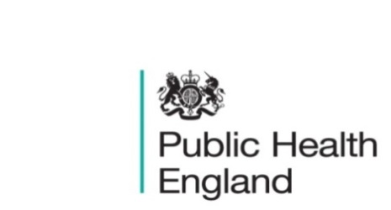
South East

PHE South East Weekly Briefing 27 November 2020

Gonococcal resistance to antimicrobials surveillance programme (GRASP) protocol
Information and procedural guidance for the national gonococcal surveillance programme.

Gonococcal resistance to antimicrobials surveillance programme report
Data on trends in antimicrobial resistance and decreased susceptibility in gonococcal infection in England and Wales are provided by GRASP.
Coronavirus and the social impacts on Great Britain: 20 November 2020
Indicators from the Opinions and Lifestyle Survey covering the period 11 to 15 November 2020 to understand the impact of the coronavirus (COVID-19) pandemic on people, households and communities in Great Britain.
Social deprivation and the likelihood of flooding
This report uses up-to-date data to provide in-depth evidence on flood risk exposure and social deprivation inequalities in England.
Wider impacts of COVID-19 on health monitoring tool
National monitoring tool that brings together metrics to assess the wider impacts of coronavirus (COVID-19) on health.
Coronavirus cases by local authority: epidemiological data, 19 November 2020
Weekly watchlist giving epidemiological coronavirus (COVID-19) data for each lower-tier local authority in England.
The State of Ageing: Coronavirus ‘to set people in mid-life on a path to poverty and ill-health’ with inequalities widening
The impact of the pandemic will also widen regional inequalities, with people in the North of England set to die younger and spend longer in ill-health. Centre for Aging Better report here.

Household wealth by ethnicity, Great Britain: April 2016 to March 2018
Examining household wealth for different ethnic groups to better understand inequalities in Great Britain. Results from the Wealth and Assets Survey.
Improving outdoor air quality and health: review of interventions
A comprehensive overview of actions that national and local government and others can take to improve air quality and health.
National Child Measurement Programme: childhood obesity
Research by University College London shares learning from local authorities that have a downward trend in childhood obesity, including practice examples.
Staying mentally well: winter plan 2020 to 2021
The government’s plans to support people’s wellbeing and mental health during the COVID-19 pandemic this winter.

Population Health Global Summit by the Kings Fund, Wednesday 2 December (free attendance)
Agenda:
- Session one: England’s population health management development system journey

Session two: International approaches to population health

Session three: how does population health enable innovation?
Register here.

Tier posters: Medium, High and Very High
A series of posters displaying information about the various tiers of restrictions in England from 2 December 2020.

Health Protection Report volume 14 (2020)
A national public health bulletin for England and Wales from Public Health England (PHE).
Making a Christmas bubble with friends and family
Meeting friends and family over the Christmas period – forming a Christmas Bubble.

PHE South East main telephone number for all locations - 0344 225 3861
Follow us on Twitter @PHE_SouthEast
If you want to be included in the mailing list for this bulletin, please contact sue.hall@phe.gov.uk

