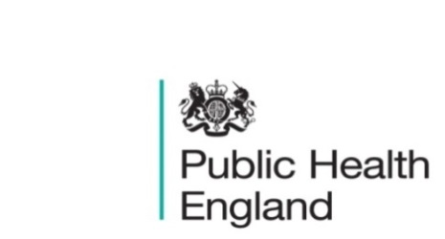
South East

PHE South East Weekly Briefing 20 November 2020

Coronavirus and the social impacts on disabled people in Great Britain: October 2020
Indicators from the Opinions and Lifestyle on the impact of the coronavirus (COVID-19) pandemic on disabled people in Great Britain.

Health Protection Report volume 14 (2020)
A national public health bulletin for England and Wales from Public Health England (PHE).

NHS Health Check Programme review
The review offers advice on how the NHS Health Checks programme can evolve and maximise its benefits to prevent illness and reduce health inequalities.
World Antimicrobial Awareness Week (WAAW)
This week has been the start of World Antimicrobial Awareness Week (WAAW), which runs from the 18-24th November 2020. The COVID-19 pandemic means that WAAW is particularly important this year as we work together to prevent serious infections and reduce inappropriate antibiotic use. You can mark this by pledging to be an Antibiotic Guardian here - this will just take a minute. If you would like to find out more about the campaign, information is available here, there is an e-learning module on antimicrobial resistance here, and resources toolkit that has been published and available here.

Launch: Reducing the health inequality gap; new framework for NHS trusts
A new resource from NHS Providers and the Provider Public Health Network (with support from Public Health England) sets out a plan of action for trusts to combat growing health inequalities in the next stage of the COVID-19 pandemic. Reducing health inequalities associated with COVID 19: a framework for healthcare providers presents a set of principles, stepped actions and examples from practice from NHS and integrated care settings, to help trusts and partner organisations understand and tackle health inequalities amongst their populations.
Comments or feedback on the framework are welcomed – please contact leanora.volpe@nhsproviders.org.

PHE South East main telephone number for all locations - 0344 225 3861
Follow us on Twitter @PHE_SouthEast
If you want to be included in the mailing list for this bulletin, please contact sue.hall@phe.gov.uk

