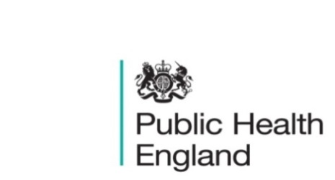
South East

PHE South East Weekly Briefing 13 November 2020

Coronavirus and the economic impacts on UK: 5 November 2020
New experimental data on the UK economy detailing the impact on businesses from the coronavirus (COVID-19). Data is from the Business Impact of Coronavirus Survey; a 2-weekly survey designed to estimate the impact over the previous 2 weeks and the expectations for the following 2 weeks.

2021 Social Prescribing Network Awards
We are so excited to be working with The College of Medicine and Chamberlain Dunn again on this awards programme, now in its second year, which recognises and celebrates the wealth of innovative social prescribing projects and schemes running throughout the UK and internationally.
This year we are expecting entries to reflect how social prescribing schemes have overcome the challenges faced during the COVID-19 pandemic. Everyone involved in social prescribing has until Monday 25th January to enter the 2021 Social Prescribing Network Awards. The awards will be presented at the 3rd International Social Prescribing Network conference on 4th and 5th March 2021.
You can hear from our co-chair Marie Polley & the award sponsors in this video highlighting why they are contributing to the awards on our new YouTube channel.

Coronavirus and the social impacts on Great Britain: 6 November 2020
Indicators from the Opinions and Lifestyle Survey covering the period 28 October to 1 November 2020 to understand the impact of the coronavirus (COVID-19) pandemic on people, households and communities in Great Britain.

National flu and COVID-19 surveillance reports
National influenza and COVID-19 report, monitoring COVID-19 activity, seasonal flu and other seasonal respiratory illnesses.

Cold weather plan for England
This plan helps prevent the major avoidable effects on health during periods of cold weather in England.

Antibiotic use and resistance: what the public know
Findings from a 2017 national household survey of public knowledge about antibiotics and antimicrobial resistance.

Health matters: cold weather and COVID-19
This edition of Health Matters covers the impact of cold weather on health during the coronavirus (COVID-19) pandemic.
Total restriction of online advertising for products high in fat, sugar and salt (HFSS)
We want your views on our proposal for a total online advertising restriction for HFSS products to reduce the amount of HFSS advertising children are exposed to online.

PHE South East main telephone number for all locations - 0344 225 3861
Follow us on Twitter @PHE_SouthEast
If you want to be included in the mailing list for this bulletin, please contact sue.hall@phe.gov.uk

