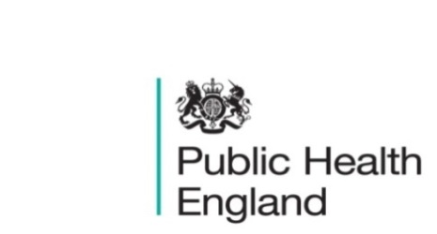
South East

PHE South East Weekly Briefing 6 November 2020

Coronavirus (COVID-19) Review: data and analysis, March to October 2020
The Compendium contains ONS data and analysis on the health, social and economic impact of COVID-19 for the period of March to October 2020. It is a stocktake of the pandemic since it began, on a thematic basis, of how society and the economy has responded so far.

Exploring substance use in prisons: a case study approach in 5 closed male English prisons
Research involved case study methodology, exploring factors associated with substance use in 5 English prisons.

Consultation on the Community Health and Wellbeing Worker apprenticeship standard now open: deadline – midday Friday 27 November 2020
The Community Health & Wellbeing Worker apprenticeship standard, that would support learning and development for people in a range of community facing roles such as health trainers, link workers, community development workers, navigators is being developed. The next stage is a consultation on the draft standard available on the Healthcare Apprenticeship Standards Online (HASO) website. If you have any questions, please contact Hannah via sp-phskf@phe.gov.uk.

Local Authority preparations for Remembrance Sunday
Information for councils in England on how to ensure those hosting local Remembrance events can do so safely.
Local tobacco control profiles for England: November 2020 update
An overview of the extent of tobacco use, tobacco related harm and the measures being taken to reduce this harm at a local level in England.

Productive Healthy Ageing Profile: November 2020 update
Updated indicators for a range of topics relevant to healthy ageing.
Adult Social Care Infection Control Fund: round 2
Sets out the infection control measures that the new infection control fund will support, including information on the distribution of funds and reporting requirements.
COVID-19: guidance on shielding and protecting people defined on medical grounds as extremely vulnerable
Information for shielding and protecting people defined on medical grounds as extremely vulnerable from COVID-19.
Community Health and Wellbeing Worker apprenticeship standard
We are asking for feedback from employers and front-line workers to inform the development of the Community Health and Wellbeing Worker apprenticeship standard.
Notifiable diseases: last 52 weeks
Notifications of infectious diseases (NOIDs) for the last 52 weeks.

PHE South East main telephone number for all locations - 0344 225 3861
Follow us on Twitter @PHE_SouthEast
If you want to be included in the mailing list for this bulletin, please contact sue.hall@phe.gov.uk

