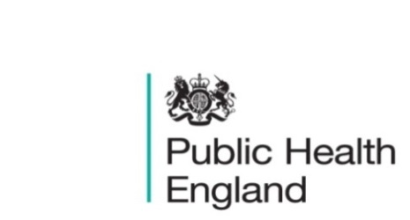
South East

PHE South East Weekly Briefing 9 October 2020 20202020

Ethnic Inequalities in the South East – a health profile (interation1)
Please see below a link to the new PHESE Ethnic Inequalities in the South East health profile:
- The advent of COVID-19 has highlighted a gap in our knowledge around ethnic groups and their health and wellbeing needs in the SE.
- The data and intelligence presented in this slide set is a health profile which aims to inform Health Needs Assessments (HNAs), rather than being a HNA in itself.
- This slide set is the first iteration bringing together data that is available split by ethnicity. It is a ‘live’ resource being developed in an agile way.
- The data intelligence in this pack is pre-COVID-19 measures and therefore will act as a baseline; it is not a measure of the impact of COVID-19 by ethnicity.
- Each section of this resource includes a summary slide which provides some context about the related impact of COVID-19.
The Ethnic Inequalities in the South East slide set is available at PHE South East Khub (open group) and SEPHIG Khub (members only group).
We would welcome feedback on what has been produced so far – please contact LKISSouthEast@PHE.gov.uk.

Hydration at home – free e-learning for carers
This free e-learning hydration module:
- Splits into four sections to:
  - Define good and poor hydration and explain their impact
  - Assess a person's hydration needs to minimise the risk of poor hydration
  - Address a person's hydration needs to improve their health and wellbeing
  - Assess learning outcomes
The course takes approx. 40 mins to complete and includes an assessment at the end where you can test your knowledge and obtain a certificate. Toolkit

Free RSPH webinar: Putting Behaviour Change into Practice, 22 October, 13:00
The webinar will include a discussion of how behaviour change principles is used within work to increase motivation and address ambivalence from these organisations:
- BeeZee Bodies, a behavioural change organisation primarily focusing on public health healthy lifestyle interventions
- Body and Soul, a charity which uses a community-based and trauma informed approach to address the life-threatening effects of childhood adversity in people of all ages.
For further information and registration for the webinar please click here.

PHE South East main telephone number for all locations - 0344 225 3861
Follow us on Twitter @PHE_SouthEast
If you want to be included in the mailing list for this bulletin, please contact sue.hall@phe.gov.uk

