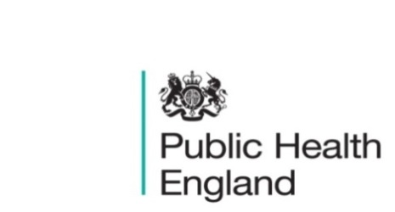
South East

PHE South East Weekly Briefing 24 July 2020

ASO webinar 'COVID-19 and obesity: A public health perspective, 30 July, 6pm to 7:30pm
The Association for the Study of Obesity UK are hosting this webinar. With presentations from Paul Niblett (PHE), Jamie Blackshaw (PHE), Ken Clare (ASO and European Coalition for People living with Obesity), Barbara Crowther (Children’s Food Campaign), followed by a panel discussion Chaired by Susan Jebb on priority actions (reflecting on the imminent government announcement on obesity).
For free registration https://fsmevents.com/aso/

Updated translated COVID-19 guidance and Roma Support Resources
Updated PHE COVID-19 guidance for the public on:
- guidance for contacts of people with confirmed coronavirus (COVID-19) infection who do not live with the person
- stay at home guidance
- guidance on shielding and protecting people defined on medical grounds as extremely vulnerable
has been translated into 10 most spoken languages, including Arabic, Bengali Cantonese, Mandarin, French, Gujarati, Polish, Portuguese, Punjabi, Urdu and we’ve provided links to this on the PHE Migrant Health Guide, under subheading “Translated advice and guidance for the public.” https://www.gov.uk/guidance/nhs-entitlements-migrant-health-guide#main-messages.

Translated resources on NHS Test and Trace are available in different formats (written and video) from Cambridgeshire County Council https://www.cambridgeshire.gov.uk/residents/coronavirus/coronavirus-covid-19-test-and-trace#test-and-trace-information-in-other-languages-5-0

The Roma Support group have also shared the following resources
- Resources for the Roma Community: General information, messages from Roma community members, information for the Slovakian community, information in Romanes and information for the Romanian community
- A video in Romanes about coronavirus
- A leaflet in Romanes about Coronavirus
- Video explaining social distancing in the Slovak Romanes dialect
- Video explaining social distancing in the Romanian Romanes dialect
- Child-friendly video "Coronavirus information for the Roma community: How to keep ourselves healthy!" in Romanes with English subtitles
- Video in Slovak Romanes providing Covid 19 guidance and encouraging people to access NHS services

PHE South East main telephone number for all locations - 0344 225 3861
Follow us on Twitter @PHE_SouthEast
If you want to be included in the mailing list for this bulletin, please contact sue.hall@phe.gov.uk

