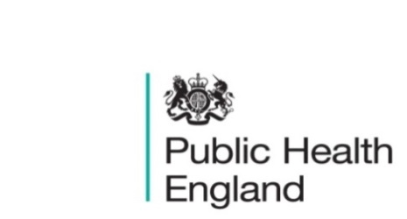
South East

PHE South East Weekly Briefing 26 June 2020

Novel coronavirus: background information
Information on novel coronavirus (COVID-19) including epidemiology, virology and clinical features. Guidance

An introduction to behavioural and social sciences applied during Covid-19, 9 July, 1pm to 2pm
A launch event for the South East Behavioural and Social Sciences Hub. The event is open to those working in the South East (Thames Valley, Wessex, Kent, Surrey, Sussex). The event is aimed at public health teams, academics, commissioners, healthcare providers and services, voluntary sector organisations, behavioural and social scientists, and those stakeholders with an interest in behavioural science approaches. The agenda is attached (subject to change). The online link will be circulated nearer the time. Click here to register

LKIS SE intelligence update – June 2020

PHE South East main telephone number for all locations - 0344 225 3861
Follow us on Twitter @PHE_SouthEast
If you want to be included in the mailing list for this bulletin, please contact sue.hall@phe.gov.uk

