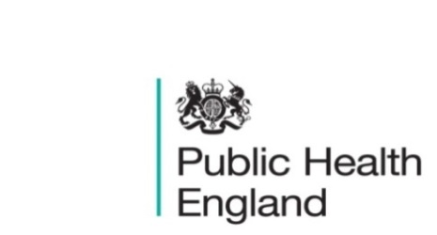
South East

PHE South East Weekly Briefing 12 June 2020

Novel coronavirus: background information
Information on novel coronavirus (COVID-19) including epidemiology, virology and clinical features. Guidance

HEE Thames Valley Public Health Training and Resources
- Behaviour Change Webinar, 11 June 2020 at 1pm
The Royal Society of Public Health held a free webinar: "Now that’s what I call behaviour change": The Greatest Hits and the Newest Interventions. The webinar will be available for 24 hours after it went live. See website for details.
- COVID Conversations

COVID Conversations is a series of short talks on YouTube about the work that the scientists at Oxford University are doing on COVID-19, including the development of a vaccine, drugs, antibody testing, communication, human sciences, and contact tracing systems. The next talk is on 10 June: “The UK’s COVID-19 digital contact tracing app”.

Previous talks can be watched on YouTube. See website for more details.

Health and Wellbeing Boards reset tool: to support HWB chairs move into the next stage of COVID-19
The LGA has developed this simple tool to support Health and Wellbeing Board (HWB) chairs/chairmen move into the next stage of COVID-19. Please adapt it to your local circumstances over the forthcoming period. Report

PHE South East main telephone number for all locations - 0344 225 3861
Follow us on Twitter @PHE_SouthEast
If you want to be included in the mailing list for this bulletin, please contact sue.hall@phe.gov.uk

