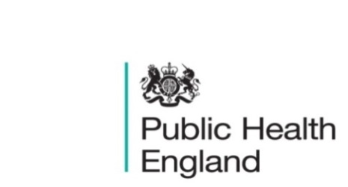
South East

PHE South East Weekly Briefing 22 May 2020

Novel coronavirus: background information
Information on novel coronavirus (COVID-19) including epidemiology, virology and clinical features. Guidance

COVID-19: Place based approach to reducing health inequalities
PHE, in collaboration with the LGA, ADPH and NHS England and NHS Improvement have collated this suite of resources to complement the wealth of existing work on health inequalities already happening at a local level.

Behaviour Change Development Framework (BCDF), 5 May webinar recording
The new BCDF website hosts a framework and toolkit for the whole system. The BCDF can support individuals in their own behaviour change development as well as help workforce leaders in developing their workforce, whether they manage a team; are responsible for an organisation’s workforce; or responsible for a workforce at a system level.
To find out more about the framework and toolkit:
- view the recording of the webinar
- visit the website
- contact PHNetwork.WX@hee.nhs.uk.

HEE Thames Valley Public Health Training and Resources

PHE South East main telephone number for all locations - 0344 225 3861
Follow us on Twitter @PHE_SouthEast
If you want to be included in the mailing list for this bulletin, please contact sue.hall@phe.gov.uk

