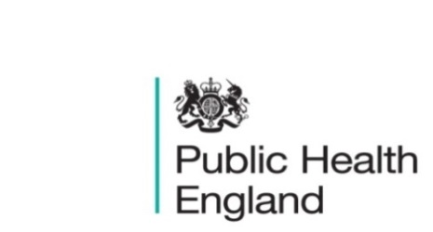
South East

PHE South East Weekly Briefing 7 May 2020

Novel coronavirus: background information
Information on novel coronavirus (COVID-19) including epidemiology, virology and clinical features. Guidance

Covid-19 updated guidance
- Covid-19: how to work safely in domiciliary care in England
- Coronavirus (Covid-19) testing: privacy information
- Contact tracing: letters to directors of public health

COVID-19: mitigating impacts on Gypsy and Traveller communities
Lord Greenhalgh, Communities Minister, has written to local authority chief executives to highlight the support needed by some members of Gypsy and Traveller communities.
COVID-19: mitigating impacts on Gypsy and Traveller communities

Health Protection Report
A national public health bulletin for England and Wales from PHE including:
- Weekly COVID-19 surveillance report
- Laboratory confirmed cases of pertussis (England): fourth quarter and annual reports for 2019
- Acute hepatitis B: national enhanced surveillance report January to December 2019
- Laboratory reports of hepatitis A infections (England and Wales): October to December 2019
- Laboratory reports of hepatitis C (England and Wales): October to December 2019
- Shingles vaccine coverage report (adults eligible from April to December 2019 and vaccinated to end-March 2020) in England
HPR vol 14 issue 8 (28 and 29 April)

Community-based care and learning disabilities: providing the right support, care and housing
This King’s Fund free online event on 28 May at 10am, will look at the challenges of moving individuals into homes in the community and how to overcome them. We will look at the lessons learned from examples where the NHS, local government, the housing sector and care providers have worked together and the challenges they faced. Register here to watch this event on 28 May or later on demand.

Statistics on Obesity, Physical Activity and Diet, England – 2020
Data on obesity, physical activity and diet from a variety of sources.
Statistics on Obesity, Physical Activity and Diet, England – 2020

Workless households and educational attainment statutory indicators, 2020
This report contains data on children in workless households and children’s educational attainment.
Workless households and educational attainment statutory indicators, 2020

PHE South East main telephone number for all locations - 0344 225 3861
Follow us on Twitter @PHE_SouthEast
If you want to be included in the mailing list for this bulletin, please contact sue.hall@phe.gov.uk

