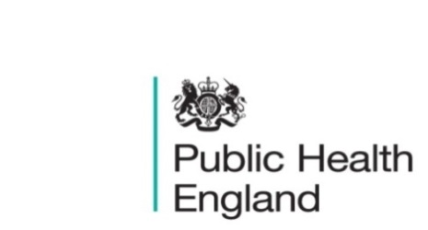
South East

PHE South East Weekly Briefing 17 April 2020

Novel coronavirus: background information
Information on novel coronavirus (COVID-19) including epidemiology, virology and clinical features. Guidance

Chancellor provides over £14 billion for our NHS and vital public services
HM Treasury confirmed on 13 April that more than £14bn from the Coronavirus emergency response fund will go towards public services, including the NHS and local authorities involved in the fight against Coronavirus.
Chancellor provides over £14 billion for our NHS and vital public services

Health Protection Report volume 14 (2020)
A national public health bulletin for England and Wales from PHE. HPR Report Vol 14 issue 7: 8 April

PHE South East main telephone number for all locations - 0344 225 3861
Follow us on Twitter @PHE_SouthEast
If you want to be included in the mailing list for this bulletin, please contact sue.hall@phe.gov.uk

