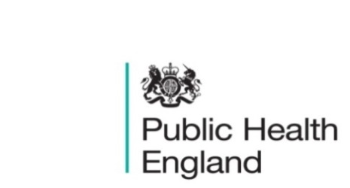
South East

PHE South East Weekly Briefing 27 March 2020

Novel coronavirus: background information
Information on novel coronavirus (COVID-19) including epidemiology, virology and clinical features. Guidance

Support for those affected by Covid-19
More information about the package of measures announced at Budget 2020 to support public services, individuals and businesses affected by Covid-19. Support for those affected by Covid-19

COVID-19: ethical framework for adult social care
A framework to support the planning and organisation of adult social care during the coronavirus (COVID-19) outbreak. COVID-19: ethical framework for adult social care

COVID-19: free school meals guidance
Guidance for schools and local authorities on free school meals arrangements during the novel coronavirus (COVID-19) outbreak. COVID-19: free school meals guidance

Oral health survey of 5-year-old children 2019
Results of the National Dental Epidemiology Programme biennial survey which took place in the academic year 2018 to 2019. Oral health survey of 5-year-old children 2019

Air pollution: applying All Our Health
Guidance to help health and care staff to work with patients, families and communities to take action on the health effects of air pollution. Air pollution: applying All Our Health

FS SEaL IID Winter Bulletin for the South East - Week 11

PHE South East main telephone number for all locations - 0344 225 3861
Follow us on Twitter @PHE_SouthEast
If you want to be included in the mailing list for this bulletin, please contact sue.hall@phe.gov.uk

