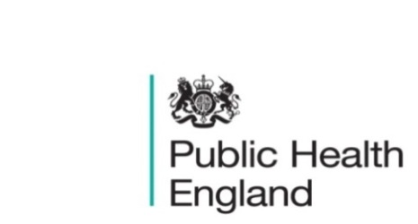
South East

PHE South East Weekly Briefing 20 March 2020

Novel coronavirus: background information
Information on novel coronavirus (COVID-19) including epidemiology, virology and clinical features. Guidance

Coronavirus bill: what it will do
Measures contained in the fast-tracked coronavirus legislation and why they are needed to effectively manage the coronavirus (COVID-19) outbreak in the UK. Coronavirus bill: what it will do

Webinar on Population Health Intelligence tools – Wednesday, 22 April 2020, 2pm to 3pm
Peter Cornish, Sarah Preece and Jo Wall, Knowledge Transfer Facilitators for PHE South East are presenting a webinar on Population Health Intelligence tools. It will highlight recent updates in functionality to some useful Population Health Intelligence tools. The tools to be covered are:
- SHAPE
- Fingertips
- Local Health
This session is aimed at people who either use or might benefit from using the tools. Register via Eventbrite here.
If you have any further queries regarding the webinar, please do not hesitate to contact LKISSouthEast@phe.gov.uk.

Public health grants to local authorities: 2020 to 2021
The public health allocations and monetary conditions for local authorities to improve health in local populations.
Public health grants to local authorities: 2020 to 2021

FS SEaL IID Winter Bulletin for the South East - Week 10

PHE South East main telephone number for all locations - 0344 225 3861
Follow us on Twitter @PHE_SouthEast
If you want to be included in the mailing list for this bulletin, please contact sue.hall@phe.gov.uk

