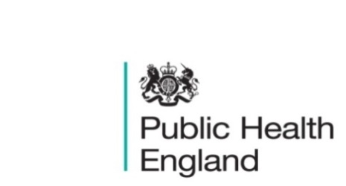
South East

PHE South East Weekly Briefing 14 February 2020

Wuhan novel coronavirus: background information
Information on Wuhan novel coronavirus including epidemiology, virology and clinical features. Guidance

e-Learning to help people living in cold homes
Health Education England e-Learning for Healthcare (HEE e-LfH) has worked with PHE to develop the Helping People Living in Cold Homes e-learning programme for health and care professionals. The e-learning resource supports health and social care professionals to put National Institute for Health and Care Excellence (NICE) guidance into practice.

Aimed at health and care staff who undertake home visits, the resource provides information on local services that can assist people living in cold homes, such as installing insulation, improving heating systems or helping reduce energy bills. It also helps people spot the signs of a cold home – including less obvious ones.

For more information about the e-learning programme, including details on how to access, visit
https://www.e-lfh.org.uk/programmes/cold-homes/.

Living longer: implications of housing tenure in later life
An examination of the implications of housing tenure for older people’s finances, housing quality, health and accessibility. Living longer: implications of housing tenure in later life

Health matters: rough sleeping
A professional resource for local authorities and commissioners on preventing and ending rough sleeping.
Health matters: rough sleeping

FS SEaL IID Winter Bulletin for the South East - Week 5

South East Influenza Report - Week 5

PHE South East main telephone number for all locations - 0344 225 3861
Follow us on Twitter @PHE_SouthEast
If you want to be included in the mailing list for this bulletin, please contact sue.hall@phe.gov.uk

