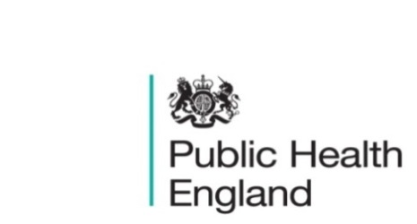
South East

PHE South East Weekly Briefing 17 January 2020

What’s in store for health and care in 2020?
This free online event will provide insight into the wider UK health and care landscape in 2020 and will explore how recent trends and future developments could affect people working in the sector, patients and members of the public. Speakers will discuss the results of the general election and what this could mean for health and care, as well as some of the big issues, including social care funding reform, population health and health inequalities, workforce, and legislative changes to support the integration agenda. To register visit The King’s Fund web site Registration.

Improving oral health: guideline development manual
Description of the methods used to develop the guideline ‘Delivering better oral health: an evidence-based toolkit for dental teams. Improving oral health: guideline development manual

Headache and migraine toolkit
Headache and migraine sufferers could soon benefit from more targeted care thanks to a new toolkit.
Headache and migraine toolkit

Mental health policy in England
Around one in four people in the UK suffer from a mental health problem each year. The NHS has set out that it wants to achieve 'parity of esteem' between mental and physical health, in terms of access to services, quality of care and allocation of resources. This briefing looks at the current mental health strategy, reform of the Mental Health Act, waiting times and the use of force in mental health settings. Briefing

Prevention concordat for better mental health: consensus statement
Describes the consensus statement of the prevention concordat for better mental health and lists the signatories.
Prevention concordat for better mental health: consensus statement

Drug health harms: national intelligence
Briefings on the health harms associated with drug use based on presentations and discussions at the meeting of the national intelligence network. Drug health harms: national intelligence

Smoke-free generation: tobacco control plan for England
Plans to reduce smoking in England, with the aim of creating a smoke-free generation. There has been a slight change to the figures in this document. Smoke-free generation: tobacco control plan for England

Local Alcohol Profiles for England: January 2020 data update
Update of Indicators in the Local Alcohol Profiles for England (LAPE) interactive tool.
Local Alcohol Profiles for England: January 2020 data update

Productive healthy ageing profile: January 2020 update
Update of indicators relating to healthy ageing, including data on older people support and specific health conditions. Productive healthy ageing profile: January 2020 update

Influenza Report South East - Week 1

FS SEaL IID Winter Bulletin for the South East - Week 1

PHE South East main telephone number for all locations - 0344 225 3861
Follow us on Twitter @PHE_SouthEast
If you want to be included in the mailing list for this bulletin, please contact sue.hall@phe.gov.uk

