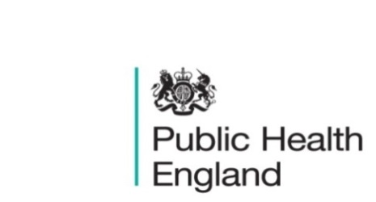
South East

PHE South East Weekly Briefing 25 October 2019

Data collection on the public health specialist workforce – closes 7 November 2019
The data collection for the Specialist Workforce across England will close on 7 November 2019. The short survey of five questions will collect data on the public health specialist/consultant and Director of Public Health roles in local authorities. The results of the data collection will inform future planning, commissioning and decision-making for public health and will be used by both national and local teams within HEE and PHE.
2019 Public Health Specialist Workforce in Local Authorities - Data Collection Tool

Healthier weight conversations: support for professionals
Outlining the shared commitment of professional organisations working together to support the public health workforce to have healthier weight conversations. Healthier weight conversations: support for professionals

Physical activity: applying All Our Health
Evidence and guidance to help healthcare professionals embed physical activity into daily life.
Physical activity: applying All Our Health

Preventing serious violence: a multi-agency approach
A resource for local partners to help them take a public health approach and work together to prevent serious violence. Preventing serious violence: a multi-agency approach

Suicide prevention: identifying and responding to suicide clusters
This toolkit, based on research of suicide clusters, is part of PHE’s support for the government’s suicide prevention strategy. Suicide prevention: identifying and responding to suicide clusters

Committee on Fuel Poverty: Interim Report October 2019
Committee on Fuel Poverty (CFP) interim advice ahead of the Annual Report.
Committee on Fuel Poverty: Interim Report October 2019

Gambling-related harms: evidence review
Information about a review of the prevalence of gambling, its associated health harms and their economic and social burden. Gambling-related harms: evidence review

Suffolk Libraries Asset report
This impact report Suffolk Libraries: A Predictive Impact Analysis, by independent consultants Moore Kingston Smith, estimates that every £1 spent on just three of Suffolk Libraries’ services creates £8.04 in ‘social value’. This is based on a study of three of Suffolk Libraries’ key activities – early years sessions for under-fives (Baby Bounce and Tot Rock), ‘Top Time’ sessions for older people and Open Space groups. The report found these three activities alone generate just under £2m of social value every year.

Health Protection Report volume 13 (2019)
A national, weekly public health bulletin for England and Wales from PHE.
HPR vol 13 issue 37: news 18 and 21 October

South East Influenza report – Week 41 2019
If you have trouble opening the report, either of the following solutions should work:
- set Chrome as your default browser (here’s how). It takes less than a minute and you only have to do it once or
- save the file to your computer/drive and open it from there

PHE South East main telephone number for all locations - 0344 225 3861
Follow us on Twitter @PHE_SouthEast
If you want to be included in the mailing list for this bulletin, please contact sue.hall@phe.gov.uk

