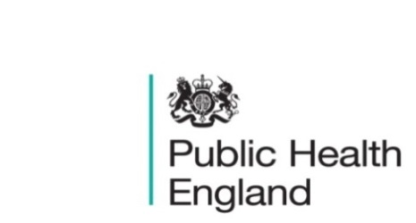
South East

PHE South East Weekly Briefing 11 October 2019

Spending at least 120 minutes a week in nature is associated with good health and wellbeing
Spending time in natural environments can benefit health and well-being, but exposure-response relationships are under-researched. Article

Smoking prevalence in young adults aged 18 to 34 years
Detailed ad-hoc analysis of smoking prevalence, calculated from the Annual Population Survey.
Smoking prevalence in young adults aged 18 to 34 years

Health Protection Report volume 13 (2019)
A national, weekly public health bulletin for England and Wales from PHE.
HPR vol 13 issue 34: news 27 September and 2 October

PHE South East main telephone number for all locations - 0344 225 3861
Follow us on Twitter @PHE_SouthEast
If you want to be included in the mailing list for this bulletin, please contact sue.hall@phe.gov.uk

