Public Health Training in Thames Valley- 2016/17
Prepared by David Munday and Sam Gale

Introduction
2016 has been a good year for the registrars in the Thames Valley. We currently have 25 Registrars in the region with 5 currently out of programme. Here is a snapshot of what we have been up to over the year;

Symposium
Our annual Registrar Symposium was held in September and was called “Marginalised Groups: closing the gap for under-served populations”. This was a well put together and very stimulating day, including sessions on prison and migrant health, polio vaccination in Syria, as well as local needle exchange and other services for those who inject drugs.

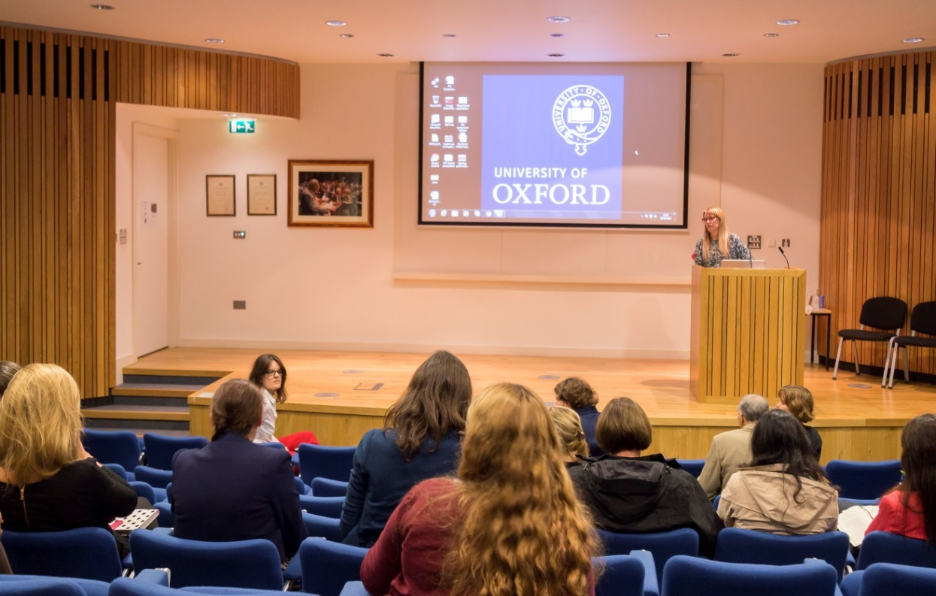

Teaching
Thames Valley StRs continue to contribute to teaching on various areas of Public Health. These include sessions on; Health Needs Assessment, Health Inequalities, Individual Funding Requests teaching for final medical students as well as teaching on Screening for MSc Public Health students.

Publications
Plugee E and Rayfield S, Systematic review and meta-analysis of the association between maternal smoking in pregnancy and childhood overweight and obesity. Journal of Epidemiology and community health, August 2016:
Briggs ADM, Mytton OT, Kehlbacher A, et al. A health impact assessment of the UK soft drinks industry levy: a comparative risk assessment modelling study. The Lancet Public Health. 2016;2(1):e15 (with press release and various media activity)

Scarborough P, Smolina K, Mizdrak A, Cobiac L, Briggs ADM. Assessing the external validity of model-based estimates of the incidence of heart attack in England: a modelling study. BMC Public Health. 2016;16:1135

Briggs ADM, Wolstenholme J, Blakely T, Scarborough P. Choosing an epidemiological model structure for the economic evaluation of non-communicable disease public health interventions. Population Health Metrics.2016;14:17

Kehlbacher A, Tiffin R, Briggs A, Berners-Lee M, Scarborough P. The distributional and nutritional impacts and mitigation potential of emission-based food taxes in the UK. Climatic Change. 2016;137(1):121-41

Briggs ADM, Kehlbacher A, Tiffin R, Scarborough P. Simulating the impact on health of internalising the cost of carbon in food prices combined with a tax on sugar-sweetened beverages. BMC Public Health. 2016;16:107

Platt L, Easterbrook P, Gower E, McDonald B, Sabin K, McGowan C, Yanny I, Razavi H, Vickerman P. Prevalence and burden of HCV co-infection in people living with HIV: a global systematic review and meta-analysis. Lancet Infect Dis. 2016 Feb 24. pii: S1473-3099(15)00485-5.
Briggs A. Sugar tax could sweeten a market failure. Nature. 2016;531(7596):551

Scarborough P, Briggs A, Mytton O, Rayner M. The Institute of Fiscal Studies’ verdict on a sugary drink tax. The Lancet. 2016;387(10024):1162

Briggs A, Newton J. Chapter 4: Physical Health. In: Davies SC. Annual Report of the Chief Medical Officer 2015. On the State of the Public’s Health, Baby Boomers: Fit for the Future. London: Department of Health. 2016(with press release and various media activity)

Posters
International Zika Summit 2016, Institute Pasteur; Paris, France (poster presentation)
The International Severe Acute Respiratory and emerging Infection Consortium (ISARIC) response to the Zika virus outbreak O Mohamed-Ahmed, B McDonald, R Pardinaz-Solis, L Sigfrid, C McMullen, S Moore, KS Longuere, P Ramon-Pardo, N Shindo, and G Carson

European Union Geriatric Medicine Society Congress in October 2016, "Rates of capacity assessment in consent processes are low despite high rates of cognitive impairment in older patients undergoing emergency surgery" Dobell E.
Presentation at the British Heart Foundation Centre of Research Excellence Symposium "The burden, treatment, control and consequences of hypertension in Cuba" Dobell E
Poster at the Faculty of Public Health Conference June 2016 “An evaluation of the thames valley practitioner development scheme” Munday D and Thomas B
Poster at the Public Health England Conference September 2016 “Suicide and the Five-year Forward View For Mental Health – Maximising the utility of local suicide audits to achieve a 10% reduction in the national suicide rate” Munday D and Culmer S.

Achievements
Award of one of the chief medical officer/HEE academic fellowships
An ST1 was awarded Best Student on MSc (for highest overall score)
One StR was successful in applying for and starting the Field Epidemiology Training Programme
Work to develop a process to produce standardised Health Inequalities briefings for local authorities was nominated for the annual PHE Quality Award
Award of Brasenose College Senior Hulme Scholarship
Oxford University Merit Award for excellence
Public Health Science Early Career Researchers Oral Presentation Prize, UK Public Health Science Conference, 2016
Award of Harkness Fellowship in Health Care Policy and Practice

